Online Registration and Tryout Passport Payments
Registration Fees will be paid for using the online Hockey Canada website. The cost for Registration remains $20 and will need to be paid online to complete your child’s registration.
NOTE: This registration fee covers CZHA (AAA), as well as CMHA (AA, A, AE,) players.
The tryout passport allows you to pay one price for all of the tryouts in advance. For NOVICE through Minor Midget the cost is $80 and covers AA, A, and AE tryouts where applicable. No matter where you start your CMHA tryouts, (AA, A, or AE) you pay one price for all tryouts you attend.
NOTE: The tryout passport covers CMHA (AA, A, AE, and MD7) tryouts but DOES NOT cover CZHA (AAA) tryouts.
HOW TO REGISTER
- Go to https://registration.hockeycanada.ca/registration/?ID=5385 or click on the blue skater.
- You will see the following screen. Login or create a login if you haven’t already done so. If you have forgotten your password click on Forgot Your Password and follow the instructions.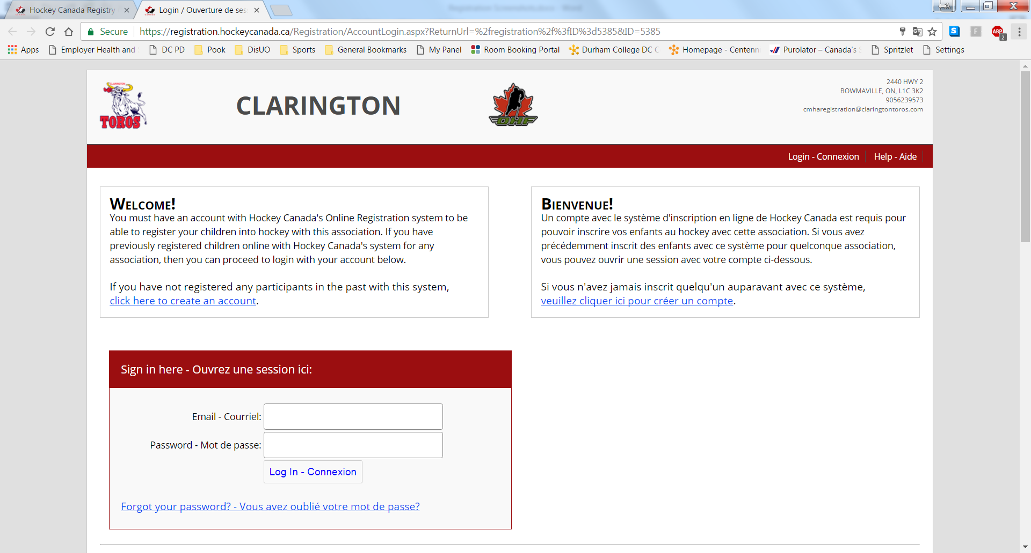
- Next Click on Register a Participant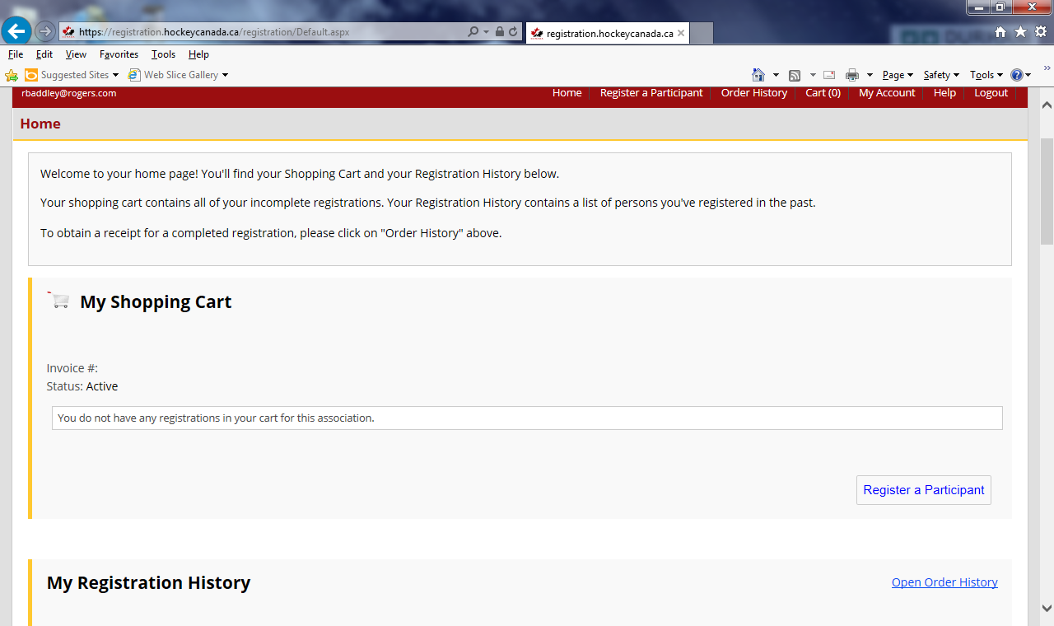

- If the player you are registering is currently registered click register next to their name. If not fill out the information to register a new participant. Then click Register below.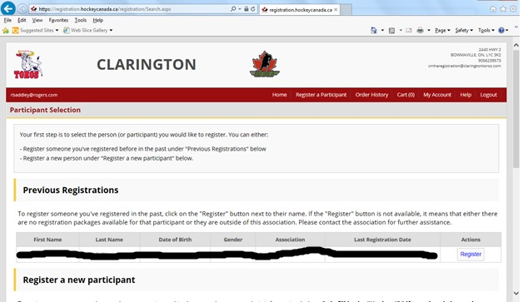

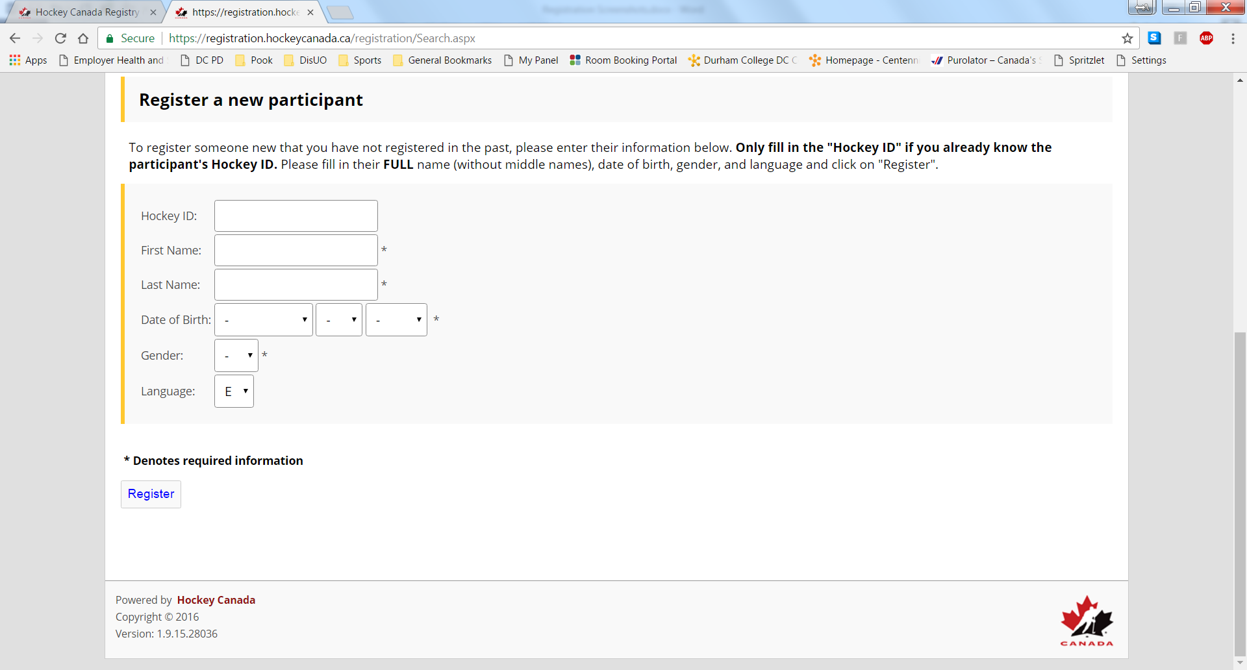

- Next Choose Participants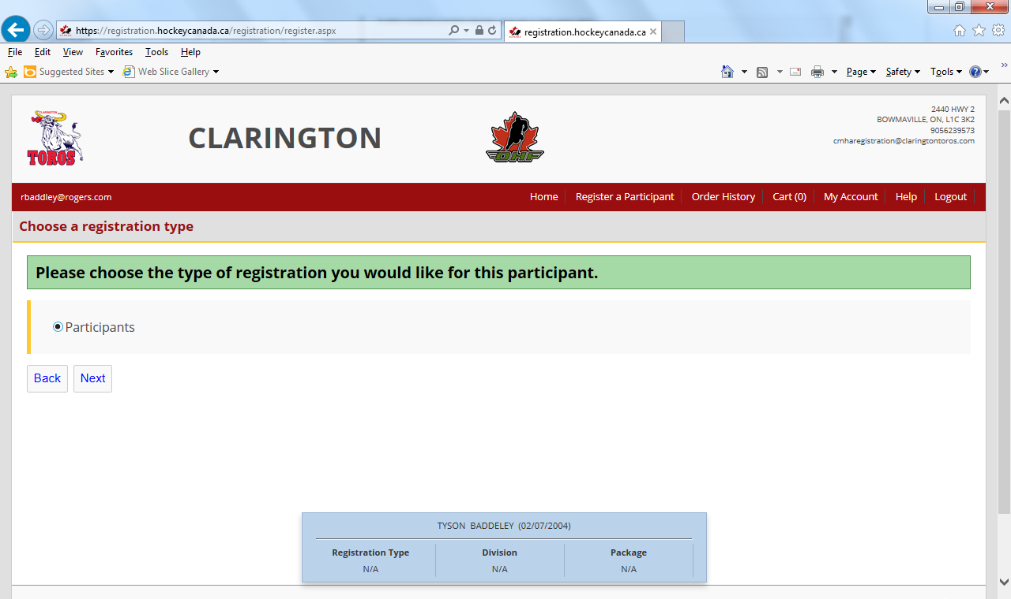
- Choose the age group (The proper one will be chosen if the birth year is entered correctly)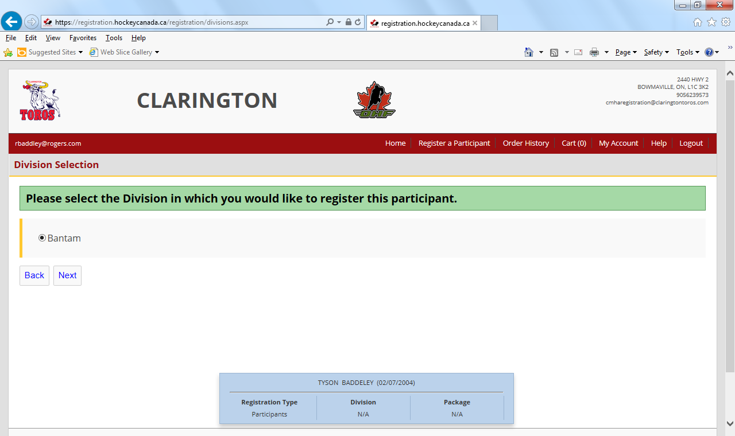
- Click SELECT next to Registration, not the Tryout Passport at this time.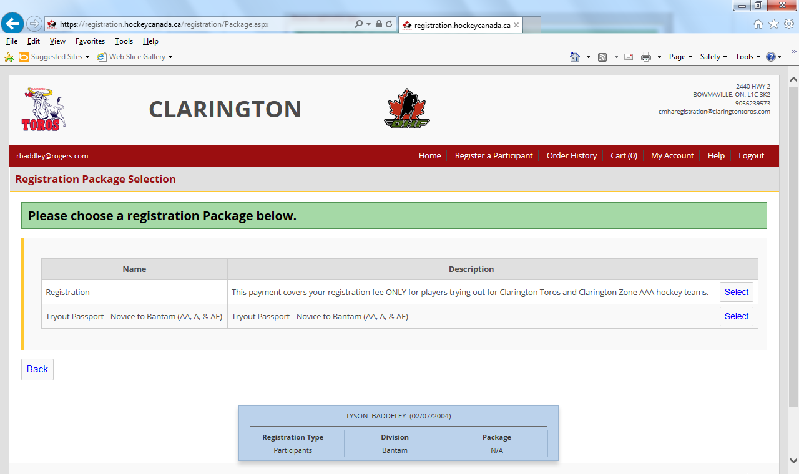
- Ensure your address is correct and fill in all required fields (* beside it).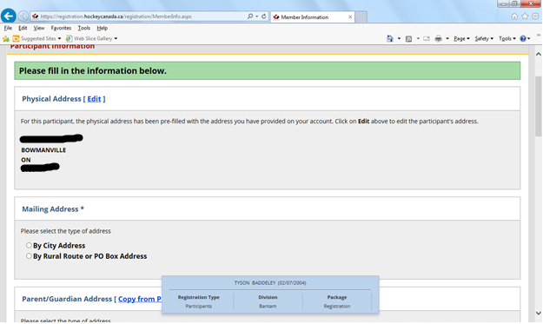
- Fill in Waiver information.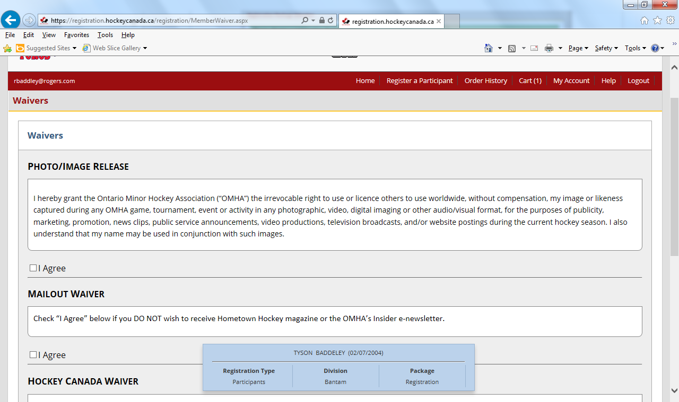
- You will see your total is $20.00. Please pay $20 ONLY, if you are attending CZHA (AAA) tryouts. DO NOT Select a passport at this time. IF YOU ARE NOT attending CZHA (AAA) tryouts, SELECT the appropriate passport at this time. You will now be paid in full for your registration fee as well your CMHA (AA,A, AE, and MD7) tryout passport. 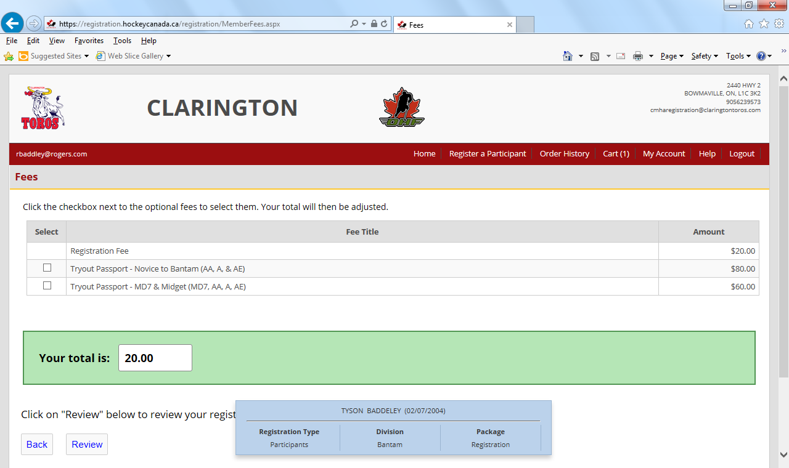
- Review all of your information.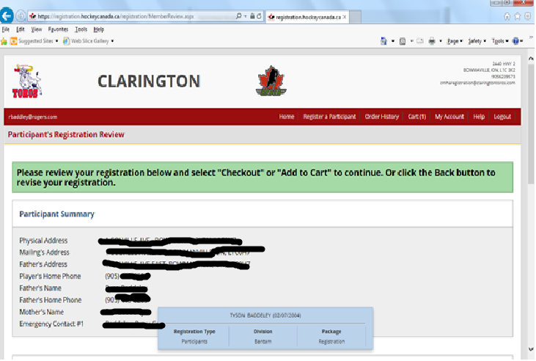
- Click Checkout.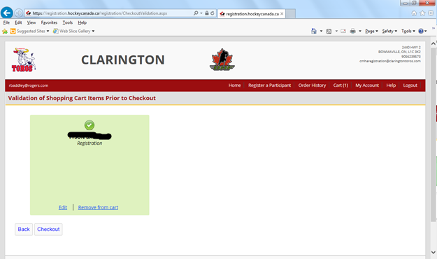
- Select Credit Card.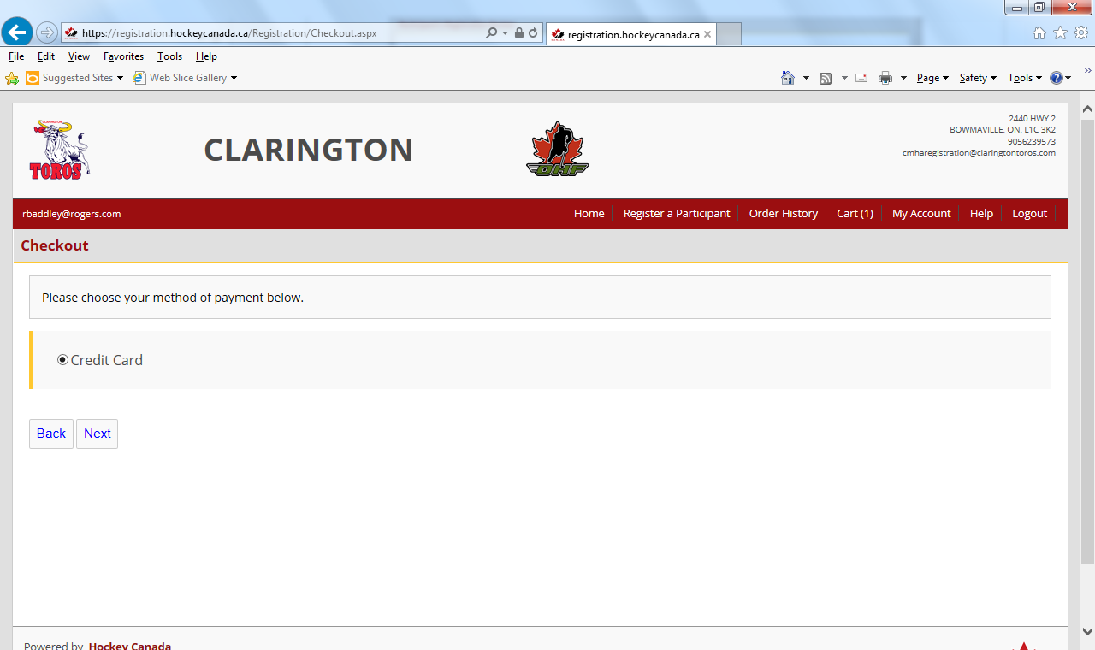
- Enter Information.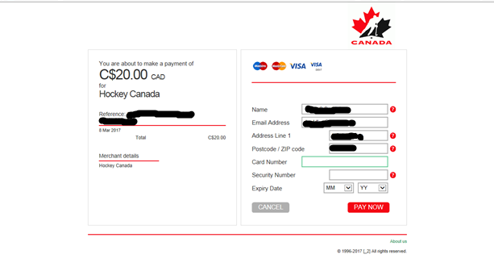
- Your transaction is now complete.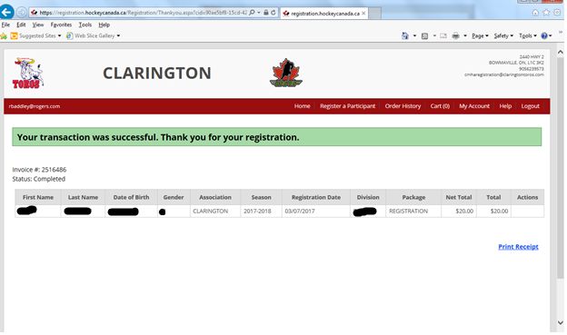
Please print out your Registration Receipt and bring it with you to tryouts

Purchasing a Tryout Passport
If your child has been released form a CZHA (AAA) team and wishes to now try out for a CMHA (AA,A, and AE) team, YOU NEED TO PURCHASE A TRYOUT PASSPORT. In order to do that please follow the instructions below. To participate in CMHA (AA, A, AE) tryouts you must be registered with Hockey Canada and have a Tryout Passport.
- Click on Register a Participant. 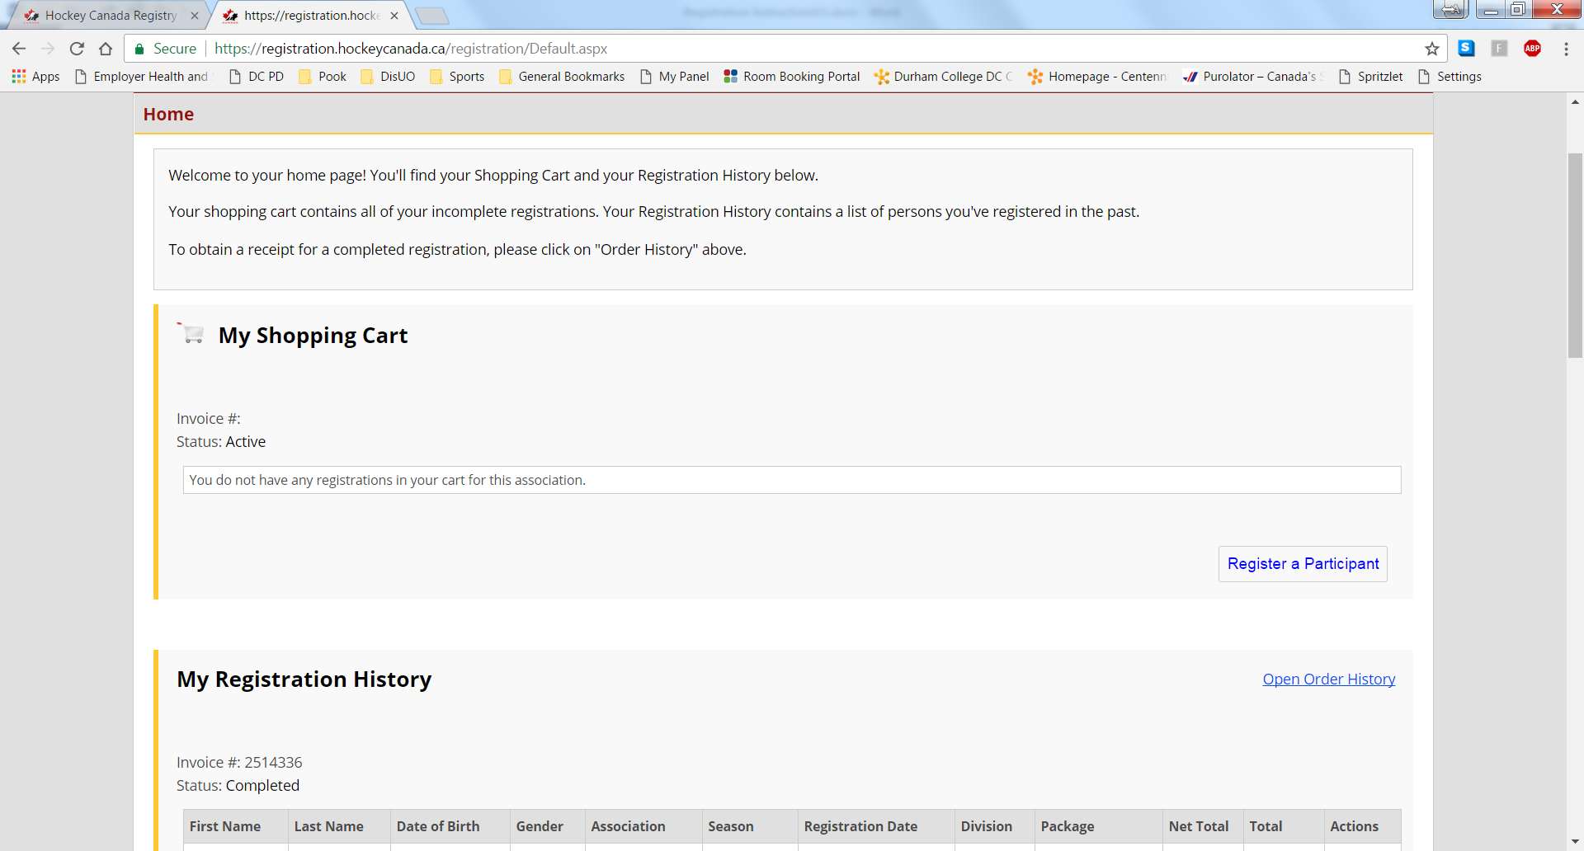
- Click Register next to the player you wish to purchase a Tryout Passport for.
- Next Choose Participants
- Choose the age group (The proper one will be chosen if the birth year is entered correctly)
- Next choose the Tryout Passport appropriate for your players age group.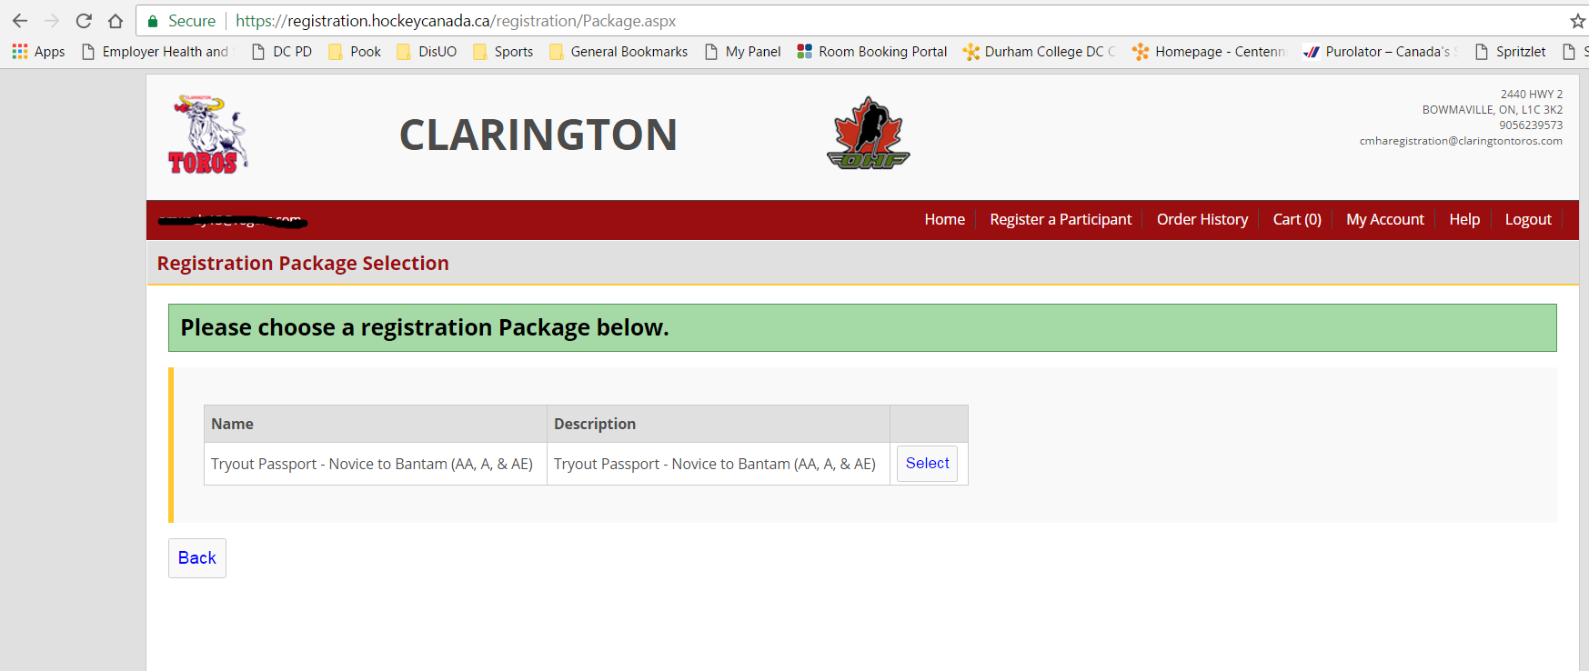
- Ensure your address is correct and fill in all required fields (* beside it).
- Fill in Waiver information.
- Select Tryout Passport and click Review. Your total will be $80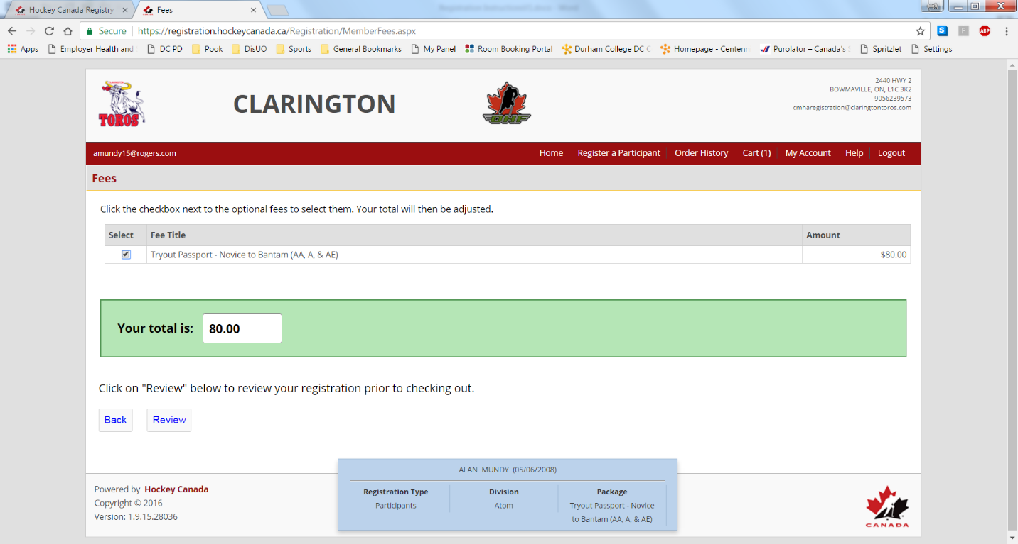

- Review all of your information and click on Checkout, or if you have another player to register or buy a tryout passport for, click on Add To Cart and follow the instructions to register another player.
- After clicking Checkout you will see the registration is confirmed and you can hit checkout again to pay.
- Select Credit Card.
- Enter Information.
- Your transaction is now complete.

At this point you should be registered with Hockey Canada and have your tryout passport paid for. Your player is now ready for Tryouts.

Please print out your Passport Tryout Receipt and bring it with you to tryouts

